Understanding Deep Learning and Neural Networks

This document provides an overview of Deep Learning (DL), Neural Networks and their types, a simplified explanation of Convolutional Neural Networks (CNN), and a brief summary of the pipeline discussed in a recent lecture. It aims to clarify these concepts for better understanding and application in the field of artificial intelligence.

Deep Learning Concepts Hierarchy





**Lecture Pipeline**

Practical application steps

**CNNs**

Specialized networks for image processing

**Neural Networks**

Core structures for DL models

**Deep Learning**

The broad field of advanced AI

# What is Deep Learning (DL)?

Deep Learning is a subset of machine learning that utilizes neural networks with many layers (hence "deep") to analyze various forms of data. It mimics the way humans learn and is particularly effective in recognizing patterns, making predictions, and processing large amounts of unstructured data such as images, audio, and text. DL has gained prominence due to its ability to achieve state-of-the-art results in tasks like image recognition, natural language processing, and game playing.

Deep Learning Hierarchy

Applications

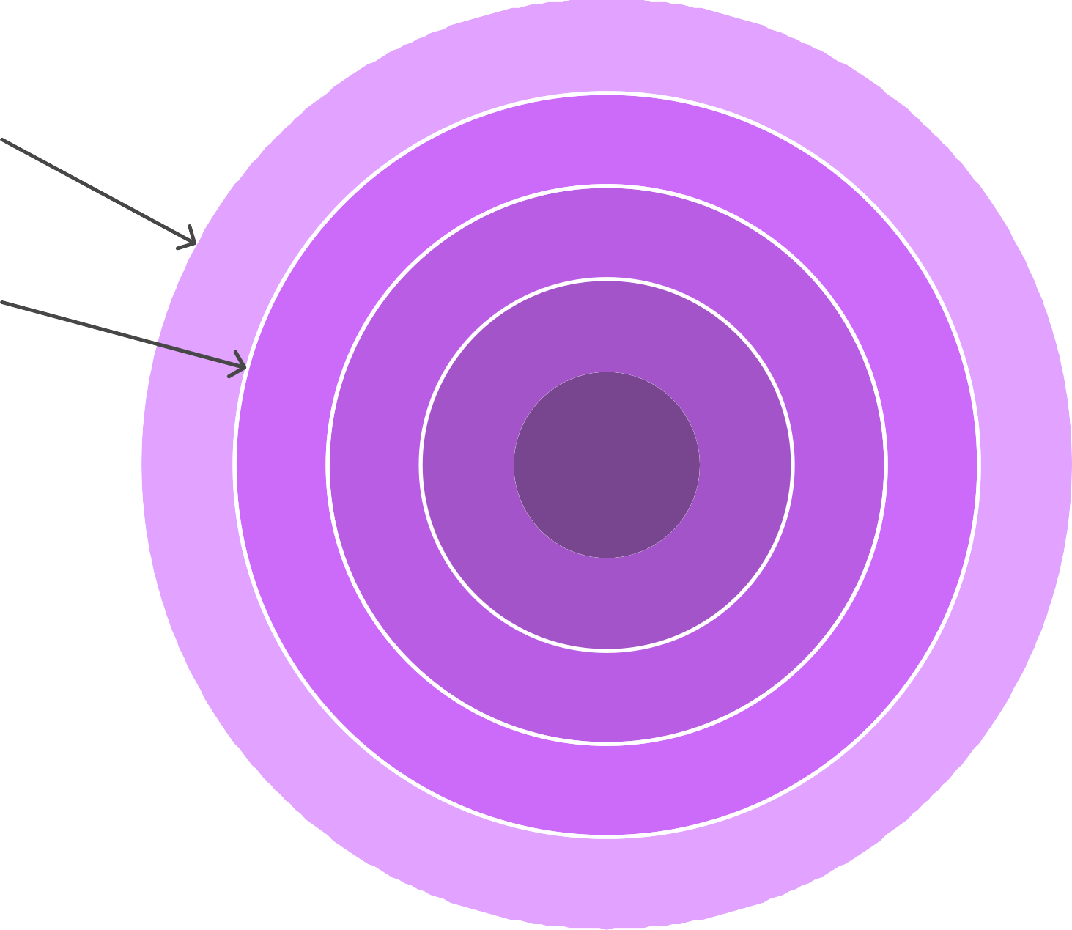

Pattern Recognition

Data Analysis

Neural Networks

Deep Learning





# What is a Neural Network and Its Types?

A Neural Network is a computational model inspired by the way biological neural networks in the human brain work. It consists of interconnected nodes (neurons) organized in layers: an input layer, one or more hidden layers, and an output layer. Each connection has an associated weight that adjusts as learning proceeds.

**Neural Network Structure**

## Hidden Layers

Intermediate processing stages

## Output Layer

Final processing result

## Input Layer

Initial data entry point

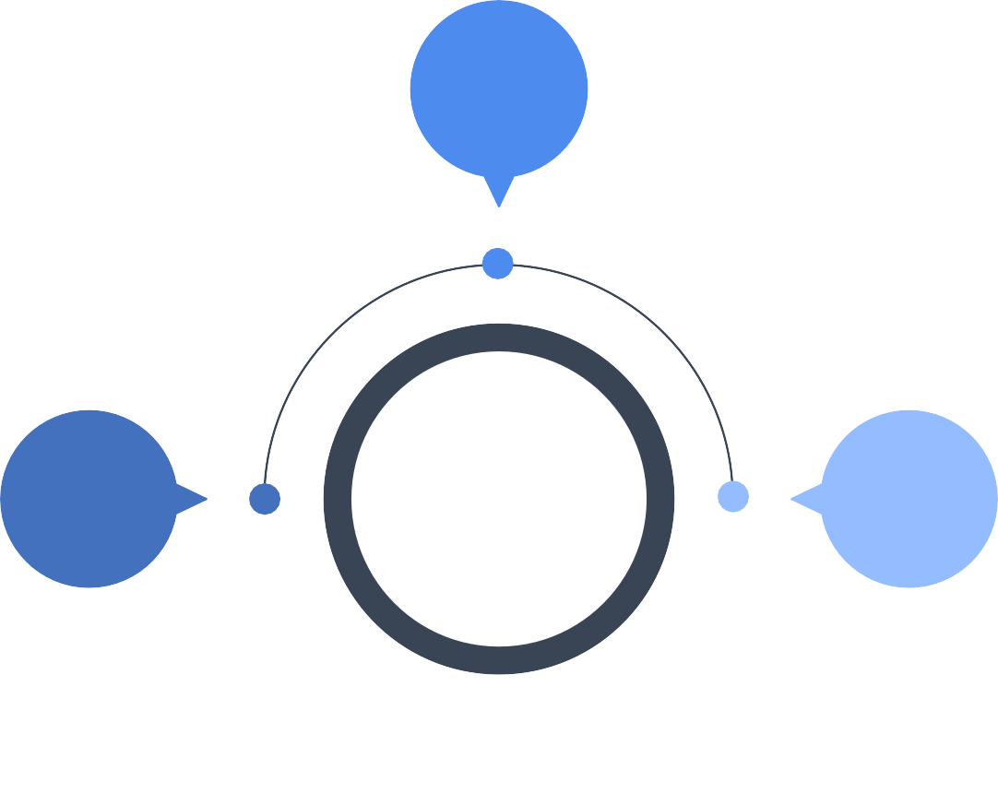

**2**

**1**

**3**



Types of Neural Networks:

1. Feedforward Neural Networks: The simplest type where connections between nodes do not form cycles. Information moves in one direction—from input to output.
2. Recurrent Neural Networks (RNNs): Designed for sequential data, RNNs have

connections that loop back, allowing them to maintain a memory of previous inputs.

1. Convolutional Neural Networks (CNNs): Primarily used for image processing, CNNs utilize convolutional layers to automatically detect features in images.
2. Generative Adversarial Networks (GANs): Comprising two networks (generator and

discriminator) that compete against each other to produce realistic data.

Types of Neural Networks





Feedforward Neural Networks

Recurrent Neural Networks

Convolutional Neural Networks

Generative Adversarial Networks

# What is CNN in Simple Words?

A Convolutional Neural Network (CNN) is a type of neural network specifically designed to process and analyze visual data. In simple terms, CNNs work by sliding small filters over an image to detect patterns such as edges, shapes, and textures. These patterns are then used to identify and classify objects within the image. CNNs are widely used in applications like facial recognition, image classification, and self-driving cars due to their efficiency in handling visual data.

CNNs in visual data

Pros

Efficient visual processing

CNNs efficiently process visual data by sliding filters over

images.

1

Pattern detection

CNNs detect patterns like edges, shapes, and textures in

images.

2

Object classification

CNNs classify objects within images using detected patterns.

3

Wide applications

4

Cons

1

High computational cost

CNNs require significant computational resources for processing.

2

Need for large datasets

CNNs need large datasets to train effectively.

3

Overfitting risk

CNNs can overfit if not properly regularized.

4

CNNs are used in facial recognition, image classification, and self-driving cars.

# Short Notes on the Pipeline Discussed in the Lecture

In the recent lecture, we discussed a typical machine learning pipeline, which includes the following steps:

1. Data Collection: Gathering relevant data from various sources.
2. Data Preprocessing: Cleaning and transforming the data to make it suitable for analysis, including handling missing values and normalizing data.
3. Feature Engineering: Selecting and creating relevant features that will help improve

the model's performance.

1. Model Selection: Choosing the appropriate machine learning or deep learning model based on the problem at hand.
2. Training: Feeding the model with training data to learn patterns and relationships.
3. Evaluation: Assessing the model's performance using metrics like accuracy, precision, and recall on a validation dataset.
4. Deployment: Implementing the model in a real-world environment for practical use.
5. Monitoring and Maintenance: Continuously tracking the model's performance and making necessary adjustments over time.

## Machine Learning Pipeline Cycle

**Monitoring and Maintenance**

Tracking performance and making adjustments.

## Data Collection

Gathering relevant data from various sources.

## Deployment

Implementing the model in a real-world environment.

## Data Preprocessing

Cleaning and transforming data for analysis.

## Evaluation Feature Engineering



Assessing model performance on validation

data.

Selecting and creating relevant features.

## Training

Feeding the model with

training data.

## Model Selection

Choosing the appropriate model for the problem.

This pipeline is essential for developing effective machine learning solutions and ensures systematic progress from data to deployment.

Machine Learning Pipeline Funnel

## Data Preprocessing



Cleaning and preparing data for analysis

## Model Training



Developing and refining the machine learning model

## Model Evaluation

Assessing the model's performance and accuracy

## Model Deployment



Implementing the model for real-world use

